Date: January 1, 2013
Version: draft H

AMSAT Fox-1

IHU Software Architecture Specification

Introduction
This software architecture document is a specification of the desired behavior of the IHU software and guidance on an overall structure for the implementation.

Document History
DATE | VERSION | SUMMARY

Document Notes
Process specifications are described in this document using a "C-like" psuedocode syntax. This is intended as high-level descriptions of the procedures and not compilable code.

References
- Concept of Operations, Version 1.03, OCT 19, 2011
- System Requirements Specification, Version 1.2, OCT 17, 2012
- IHU to Battery Interface Control Document, Version 1.01, November 7, 2012
- IHU to PSU Interface Control Document, Version 1.04, November 7, 2012
- Radiation Experiment Interface Control Document ???
- Camera Interface Control Document ??
- Downlink Protocol Specification ???

Processing Environment

Microcontroller
The IHU software will run on an STMicroelectronics STM32L151VBT microcontroller. The CPU is an ARM® Cortex™-M3 processor with a maximum clock speed of 32 MHz. This is a 32-bit processor and it provides up to 33 MIPS of processing power. The microcontroller includes 128K bytes of FLASH program memory, 4K bytes of non-volatile EEPROM and 16K bytes of RAM.

MRAM
The IHU card includes an Everspin Technologies MR25H10 MRAM. This is a 128K byte, non-volatile, read-write memory. The MR25H10 is highly tolerant of space radiation and is expected to be error-free during on-orbit operation. However, it is connected to the microcontroller through an SPI bus interface which may be sensitive to space radiation effects. Therefore, as a minimum, a single-bit-error detection scheme should be used to detect errors that might be induced during SPI transfers. This can be easily accommodated with a 16-bit checksum of 8-bit bytes for each data structure stored in the memory. Writes to the MRAM should be immediately followed by a read-verify operation to insure that the write was successful. A retry scheme should be used to handle detected errors.

MicroSD Card
The IHU has the capability of hosting a microSD FLASH memory card. This is not expected to be used for the initial Fox-1 satellite mission but is available for software development if desired.

I/O Interfaces
The IHU microcontroller includes the following types of on-chip I/O interfaces:

Type | Description
A/D | Analog to Digital Converter (input)
D/A | Digital to Analog Converter (output)
I2C | I2C bus
GPI | General Purpose IO (used as input)
GPO | General Purpose IO (used as output)
Serial-I | Asynchronous serial input
Serial-O | Asynchronous serial output
SPI | SPI Bus

The above "Type" codes are used in the next section to indicate how peripheral device signals are interfaced with the IHU microcontroller.

Peripheral Devices
This section describes the IHU peripherals and their interfaces to the microcontroller. See the IHU card documentation for the specific port and pin information. It would probably be very helpful to create a cross-reference between the Fox-1 bus signals and the STM32 port/pins.

MEMS Gyroscopes
The IHU card includes a pair of STMicroelectronics, LPY403AL, 2-axis MEMS gyroscopes. They are physically arranged so that 3-axis of angular velocity can be measured. The GPIO outputs on the microcontroller are used to control the operation of the gyros and the gyro outputs drive A/D inputs on the microcontroller.

The interface is as follows:

Name | Type
Gyro HP | GPO
Gyro ST | GPO
Gyro_Vref_1 | A/D
Gyro_Vref_2 | A/D
Gyro_X_1 | A/D
Gyro_Z_1 | A/D
Gyro_X_2 | A/D
Gyro_Z_2 | A/D

Note that the Gyro_Z_2 channel provides duplicate information and is not used.

Looking down at the top (+Z) of the satellite, a Gyro_Z_1 voltage above the Gyro_Vref_1 voltage indicates a counter-clockwise rotation about the satellite's Z axis.

Looking straight at the +Y solar panel of the satellite, a Gyro_X_1 voltage above the Gyro_Vref_1 voltage indicates a counter-clockwise rotation about the satellite's Y axis.

Looking straight at the +X solar panel of the satellite, a Gyro_X_2 voltage above the Gyro_Vref_2 voltage indicates a clockwise rotation about the satellite's X axis. This is opposite from the other axis and must be multiplied by -1 to be consistent when reported.

Refer to the LPY403AL spec sheet to understand how to test (for diagnostics) and operate the MEMS gyro devices.

Antenna Deployer Control
These signals activate the antenna deployment mechanisms and sense the deployment status. The precise sequencing and operation of these signals is TBD.

Name | Type
TX Antenna Sensor | GPI
RX Antenna Sensor | GPI
TX Antenna Deploy | GPO
RX Antenna Deploy | GPO

Radio Control
These are the signals used to operate the RF up and down links.

Name | Type
Command Mode | GPO
IHU_PTT | GPO
IHU_Audio_1_Out | D/A
IHU_Audio_2_Out * | D/A
RX_CD * | GPI
RX PTT * | GPI
Rx_Audio_1 | A/D
Rx_Audio_2 * | A/D

* For Fox-1, the IHU_Audio_2_Out, RX_CD, RX_PTT and Rx_Audio_2 signals are not used by the IHU software.

IHU Card Telemetry
These are the telemetry parameters from sensors on the IHU card.

Name | Type
IHU CPU Temperature | A/D

External Watchdog Timer
In addition to the STM32 internal watchdog timer, the IHU card has an external watchdog timer. The IHU software must pulse the "Watchdog" lead at least once per second. Failure to do this will cause the IHU to be power-cycled.

Name | Type
Watchdog | GPO

Hardware Command Decoder
There is a 4-bit, hardware command decoder on the RF Rx card. The 4 output bits and a data valid strobe are available on the IHU card on GPIO leads. The decoder output bits 8-11 are latched. The data valid strobe is a rising edge and is not latched. At satellite power up, all signals will be 0.

Output | Type
RX Command Data11 | GPI
RX Command Data10 | GPI
RX Command Data9 | GPI
RX Command Data8 | GPI
RX Command Strobe | GPI

The most significant bit (Data 11) is used to inhibit the RF transmitter. The second most significant bit (Data 10) is used to inhibit the IHU (i.e. power off.) These are implemented in hardware and operate without any software intervention. The commands are coded as follows:

Bit Pattern | Command
1xxx | Inhibit TX
0xxx | Enable TX
x1xx | Inhibit IHU (power off)
x0xx | Enable IHU (power on)
xx00 | Go To Transponder Mode
xx01 | Go To Data Mode
xx10 | Clear Telemetry Min/Max data
xx11 | Send Test Message

RF System Telemetry
These are analog sensors on the RF cards that feed A/D inputs on the STM32.

Parameter | Type
TX PA Current | A/D
TX PA Temperature | A/D
TX Osc Temperature | A/D
RX Osc Temperature | A/D

Battery Card Telemetry
These data elements come from the Battery card via an I2C interface that is shared with the PSU card. See the IHU to Battery Interface Control Document for more details.

Parameter
Battery Cell 1 Volts
Battery Cell 2 Volts
Battery Cell 3 Volts
Battery Cell 4 Volts
Battery Cell 5 Volts
Battery Cell 6 Volts
Battery Pair 1 Temperature
Battery Pair 2 Temperature
Battery Pair 3 Temperature
Battery Card Current*
BAT CPU Temperature

*Note: Total current into (charge) or out of (discharge) the card.

PSU Card Telemetry
These parameters come from the PSU card via an I2C interface that is shared with the Battery card. See the IHU to PSU Interface Control Document for more details.

Parameter
+X Solar Panel Volts
-X Solar Panel Volts
+Y Solar Panel Volts
-Y Solar Panel Volts
+Z Solar Panel Volts
-Z Solar Panel Volts
+X Solar Panel Temperature
-X Solar Panel Temperature
+Y Solar Panel Temperature
-Y Solar Panel Temperature
+Z Solar Panel Temperature
-Z Solar Panel Temperature
Satellite Spin Rate*
Total Output Current
PSU CPU Temperature

*Note: the satellite spin rate is calculated on the PSU card from the solar panel voltages and is only meaningful when the satellite is in sunlight.

USB Umbilical Port
The umbilical port is functionally a USB port. The USB port can provide power to the satellite avionics and can be used to charge the satellite batteries. Since battery charging will exceed the standard USB current capability, a special power adapter will be used when charging the batteries. A GPIO input lead will indicate that the USB port is providing power to the satellite.

To the USB host, the satellite will look like a COM port and will allow use of the standard host USB COM driver. The intention is that the satellite can be easily used with common terminal emulation programs such as PuTTY. This port is used by the Diagnostics Subsystem that is described later in the document.

Debug Port
This is a serial port available for SW development use. It is not needed or used for the mission. It is expected that a call to a debug "printf()" would direct the output string to the debug port. It is expected this port would use asynchronous ASCII 8 Data bits, no parity, 1 stop bit, 19.2 k bps. As an alternative, the Umbilical port could be enhanced to display software debug messages rather than use a dedicated serial port. This port could be used for a debugger such as GDB if desired.

Radiation Experiment
Power to the radiation experiment cards is controlled via a GPIO output that drives the "Experiment Enable 1" bus signal.

An I2C bus is used to get the radiation experiment data. The specifics of this interface are defined in the Fox-1 Experiment Interface Control Document.

Camera
Power to the camera card is controlled via a GPIO output that drives the "Experiment Enable 4" bus signal.

A serial port is used to send commands to the camera and to get the camera image data. The specifics of this interface are defined in the Fox-1 Camera Interface Control Document.

CPU Start Up Sequence
This is the sequence of events after a CPU reset or at power up.

// Run Power On Self Test (POST)
// Check the program FLASH and run a CPU test
// Remember to pulse the external watchdog timer!

Run POST;
if (POST Failed) {
halt and let external watchdog timer fire to try again
}

// POST passed
// See if we need to deploy the antennas
if (Umbilical Port is providing power) {
break; // do NOT deploy antennas!
}
else if (Both antennas are already deployed) {
break; // no need to deploy antennas
}
else if (One antenna is already deployed) {
Deploy remaining antenna;
break;
}
else {
// Just released from P-POD
// Antennas not deployed
wait for 45 minutes; // remember to pulse Watchdog
Deploy RX antenna;
Deploy TX antenna;
break;
}

increment IHU Reset Count in MRAM;
set Command Mode to HIGH;
boot up system;

Application Software Data Flow Diagram
This shows the application software subsystems and their interfaces after the start up sequence has been executed (i.e. after system boot up.) The required functionality of each subsystem is specified in this section.

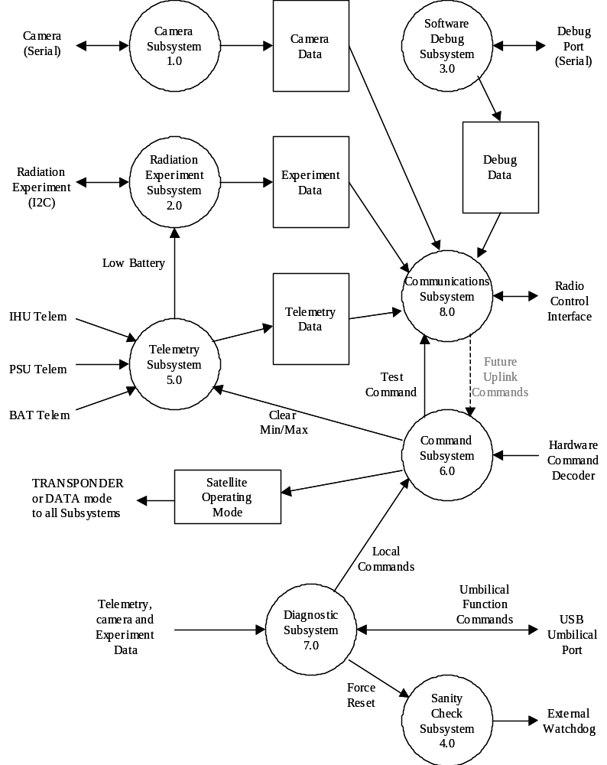

Camera Subsystem (1.0)
This subsystem runs the camera. The Camera is only used in DATA mode.

// Camera Processing
// Satellite in DATA mode

Turn ON power to Camera Card;
Initialize Camera parameters;

while (Satellite is in DATA mode) {
Tell Camera to take a snapshot;

while( Camera has data to send) {
Get data from Camera;
Store in Camera Data Buffer
}
Send Camera Data to Communications Subsystem;
}

// If Satellite switched to TRANSPONDER mode
Turn Camera card OFF;
Clear Camera Data Buffer;
Do nothing until satellite switches to DATA mode;

Radiation Experiment Subsystem (2.0)
This subsystem is responsible for running the experiment, collecting the experiment data , putting the experiment data into the Experiment Data Buffer and sending it to the Communications Subsystem. The experiment must be turned off and processing stopped if the Low Battery indication is received from the Telemetry subsystem.

Software Debug Subsystem (3.0)
There are no flight requirements for this subsystem. It is available for software development purposes and will be disabled for flight. There is a serial debug port that may be used for simple messages (printf.) There is also a debug data store available that will allow data to be transmitted along with the telemetry data on the downlink. This will allow non-flight parameters to be provided during software development.

Sanity Check Subsystem (4.0)
This subsystem verifies the integrity of the running software and pulses the Watchdog signal to reset the external watchdog timer. It will stop pulsing the Watchdog signal if it detects a fault or if it receives a command from the Diagnostic subsystem to force a reset.

Telemetry Subsystem (5.0)
This module is responsible for collecting all of the telemetry information from the interfaces, doing the Min/Max processing and providing the complete set of real-time, minimum and maximum telemetry parameters in the Telemetry Data Buffer. Note that this data is to be in the packed binary format as specified in the Telemetry Data section of the Downlink Protocol Specification.

Telemetry Subsystem Processing Specification

// Telemetry Processing
Do this every 15 seconds;

Get all telemetry parameters;

// Check Battery
If (Bus Voltage < 3.5 volts) {
Send LOW BATTERY indication to Radiation Experiment Subsystem;
}

// Do MinMax processing
Read Min/Max Data from MRAM memory;
If (any errors) {
Increment MRAM memory error counter;
Re-write data to clear errors;
}
if (Clear Min/Max command was received) {
Write current telemetry values to Min/Max;
Clear MRAM memory error counter;
}
else {
// Normal Min/Max processing
Compare current values with stored Min/Max data;
Write any new Min/Max data to MRAM memory
}

Send telemetry data to Communications Subsystem

Command Subsystem (6.0)
This subsystem is responsible for interpreting and executing commands to the satellite. The commands can come from ground control stations via the Hardware Command Decoder interface or from the Diagnostics subsystem via the umbilical port. In the future, the satellite will also accept commands from the communications subsystem via the uplink (not implemented for Fox-1.)

The Local Commands from the Diagnostics subsystem are:
- Clear Telemetry Min/Max data
- Got to Transponder Mode
- Go to Data Mode
- Send Test Message

The Command subsystem is responsible for setting the satellite operating mode. This is used by several subsystems to control their operation. If the satellite is commanded into DATA Mode, it must automatically switch back to TRANSPONDER mode after 24 hours unless a new DATA Mode command has been received.

Command Subsystem Processing Specification

// Command Processing
Set Satellite Operating Mode to TRANSPONDER; // This is the default at power-up

Do this continuously {

Wait for a new command;
switch(command) {

case Clear Telemetry MinMax:
Send Clear Min/Max message to Telemetry subsystem
break;

case Transponder Mode:
Stop 24 Hour timer;
Set Satellite Operating Mode to TRANSPONDER;
break;

case Data Mode:
Start or re-start the 24 hour timer;
Set Satellite Operating Mode to DATA;
break;

case Send Test Message:
Send Test Command to Communications subsystem
break;
default:
// No processing for TX and IHU INHIBIT or ENABLE commands
Do nothing;
}

if (24 hour timer expires) {
Set Satellite Operating Mode to TRANSPONDER;
}
}

Diagnostic Subsystem (7.0)
This subsystem implements a local user interface on the satellite through the Umbilical USB port. This is expected to be used for system testing and launch integration activities. The Diagnostic Subsystem can read data from any Data buffer and can send commands to the Command and Idle subsystems. It is also available for software development use. This subsystem is not used in orbit. Note that if the satellite is being powered by the USB Umbilical port, the antennas MUST NOT be deployed and the Communications subsystem will prevent the transmitter power amp from being activated.

The following functions are the minimal set that is required. Additional commands can be added as needed.

Umbilical Port Get Functions
- Get Telemetry Data
- Get Experiment Data (n= 1-4)
- Get Satellite Mode (command or transponder mode)
- Get Satellite Up time (MET)
- Get IHU Reset Count
- Get Software Versions (IHU, PSU, BAT)

Umbilical Port Set Functions
  - Load the CPU Program (FLASH) Memory
  - Clear Telemetry Min/Max data
  - Clear IHU Reset Count
  - Clear MRAM error count
  - Got to Transponder Mode
  - Go to Data Mode
  - Send Test Message
  - Reset CPU (let external watchdog timer fire)
  - Force Antenna Deployment (only if NOT powered by USB port)

Communications Subsystem (8.0)
This subsystem operates differently in TRANSPONDER and DATA modes.

Communications Subsystem TRANSPONDER Mode Operation
The diagram below shows the Communications subsystem data flow in TRANSPONDER mode.
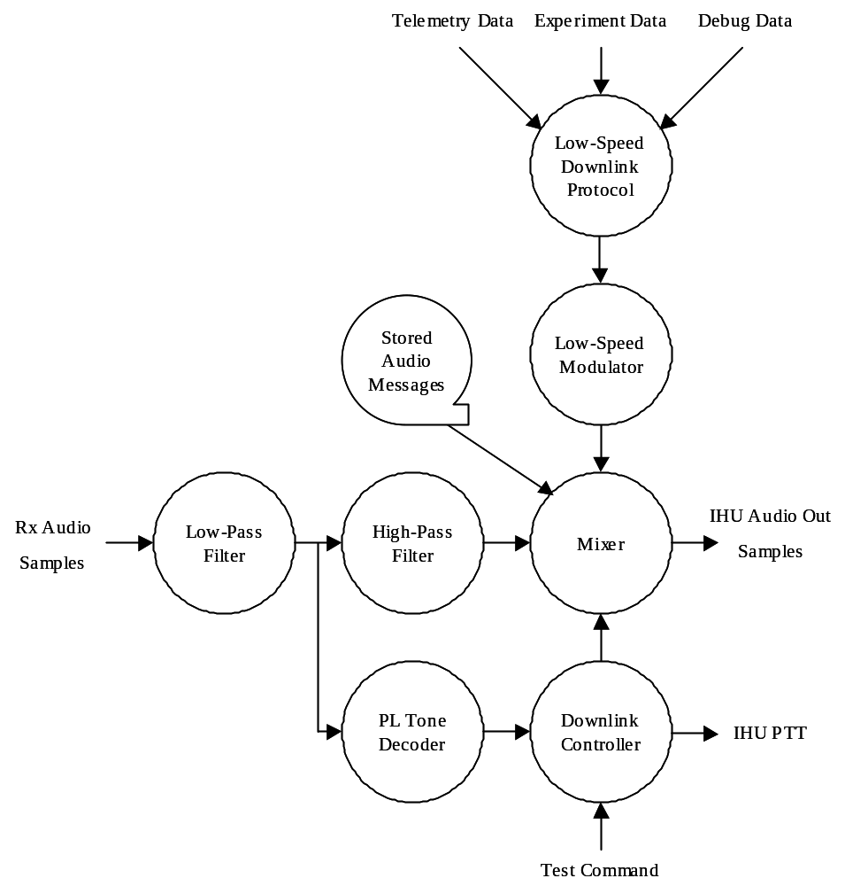

The Low-Speed Downlink Protocol multiplexes the Telemetry, Experiment and Debug Data and adds the header and forward error correction (FEC) fields as specified in the Downlink Protocol Specification. The resulting bit-stream is fed to the Low Speed Modulator which creates the audio samples for transmission.

The Rx audio samples from the RF receiver are sent to a 3 kHz low-pass filter which feeds a 300 Hz high-pass filter and the PL Tone detector. The high-pass filter removes all of the audio components below 300 Hz so the spectrum is clean for the low-speed data downlink signal. The filtered audio signal is sent to the Mixer.

The Mixer can select and combine the low-speed data downlink signal and the filtered Rx audio signal or a Stored Audio Message under control of the Downlink Controller. The Stored Audio Messages include the Beacon message, Test message and Silence.

The PL Tone decoder detects the presence of a 67 Hz PL tone and sends an indication of this to the Downlink Controller.

Downlink Controller - TRANSPONDER mode Processing Specification

// Downlink Controller TRANSPONDER mode Processing

When satellite enters TRANSPONDER mode {
Turn off IHU PTT;
Set Mixer source to Rx Audio and Low-Speed Modulator;

}

do {
if (PL Tone Detected) {
if( NOT powered from USB port ) {
Turn on IHU PTT;
}
Start or restart 2-minute Hang Timer;
Stop Idle Timer;
}

if (Hang Timer Expires) {
Turn off IHU PTT;
Start 2 minute Idle Timer;
}

// continued on next page
if (Idle Timer Expires) {
Set Mixer source to Silence;
if( NOT powered from USB port ) {
Turn on IHU PTT;
}
Wait 5 seconds;
Set Mixer source to Low-Speed Modulator and Beacon Message;
Wait until Beacon Message sent;
Set Mixer source to Low-Speed Modulator and Silence;
Wait 6 seconds;
Turn off IHU PTT;
Set Mixer source to Rx Audio and Low-Speed Modulator;
Re-start Idle Timer;
}

if (Test Command received) {
if( NOT powered from USB port ) {
Turn on IHU PTT;
}
Wait 1 second;
Set Mixer source to Test Message and Low-Speed Modulator;
Wait until Test Message sent;
if (Hang Timer is not running) {
Wait 1 seconds;
Turn off IHU PTT;
}
Set Mixer source to Rx Audio and Low-Speed Modulator;
}
}
// end of TRANSPONDER mode, downlink controller processing

Communications Subsystem Data Mode Operation
The diagram below shows the Communications subsystem data flow in DATA mode.

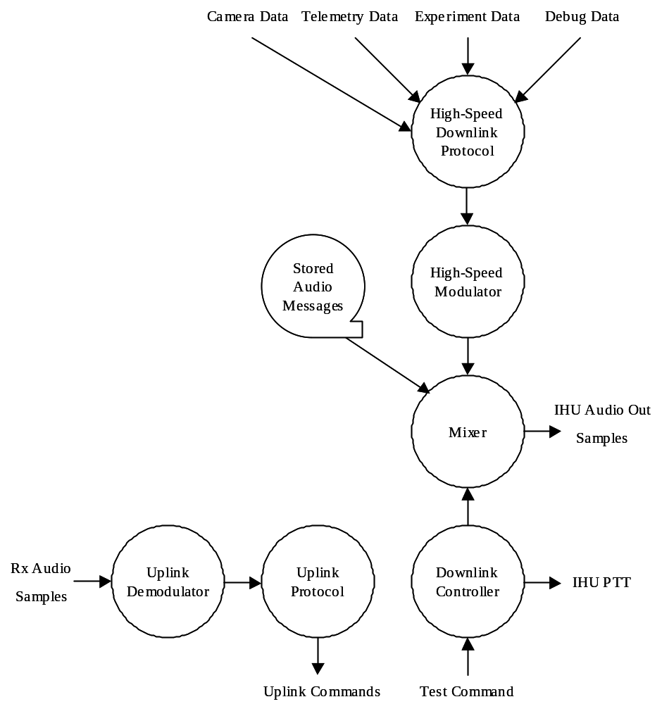

The High-Speed Downlink Protocol multiplexes the Camera, Telemetry, Experiment and Debug Data and adds the header and forward error correction (FEC) fields to create downlink frames. The resulting bit-stream is fed to the High-Speed Modulator which creates the audio samples for transmission. The Mixer can select the Modulator samples or a selected Stored Audio Message under control of the Downlink Controller. The Stored Audio Messages include the Beacon message, Test message and silence. The uplink demodulation and protocol functions are not implemented in Fox-1 but are shown for completeness.

Downlink Controller DATA mode Processing Specification

// Downlink Controller DATA mode Processing

When Satellite enters DATA mode {
Set Mixer Source to High-Speed Modulator only;
if( NOT powered by USB port ) {
Turn on IHU PTT;
}
}

do {
if (Test Command received) {
Set Mixer source to Silence;
Wait 1 second;
Set Mixer source to Test Message;
Wait until Test Message sent;
Set Mixer source to Silence;
Wait 1 second;
}
Set Mixer Source to High-Speed Modulator;

} while (satellite is in DATA mode)

// Satellite switched to TRANSPONDER mode
Turn off IHU PTT;
Do nothing until satellite goes back into DATA mode;

System Considerations

Operating System
The IHU software will use the free version of the FreeRTOS operating system.

Physical Device Drivers
These physical device drivers are needed to access and control the STM32 I/O interfaces.

  - I²C Bus
  - SPI Bus
  - UART
  - A/D converter channels
  - D/A converter channels
  - GPIO inputs
  - GPIO outputs

Performance Requirements
The Rx Audio A/D and the IHU Audio D/A converters have hard real-time requirements. DMA should be considered to offload the CPU for these interfaces.

Operational Constraints
The software is intended to run on orbit but must also be able to run inside the P-Pod to support the launch integration activities. Inside the P-POD, the power for the satellite will come from the USB Umbilical port. When powered from this port (i.e. inside the P-POD,) the antennas MUST NOT be deployed and the RF transmitter power amp MUST NOT be turned on.

Modularity and Maintainability
The experiments will be different for each future Fox-1 type satellite mission. The experiment and camera processing software needs to be modularized so that they are easy to change.

Closing Notes
This document provides the desired behavior and a structure for the IHU software. It is expected that appropriate design documentation will be provided in addition to this document to describe the implementation details.

